Assignment: Parameters and Filters
By: Aaditya Malathy

Chart 1: Hospital Ratings by Type and Ownership (TX Vs CA):
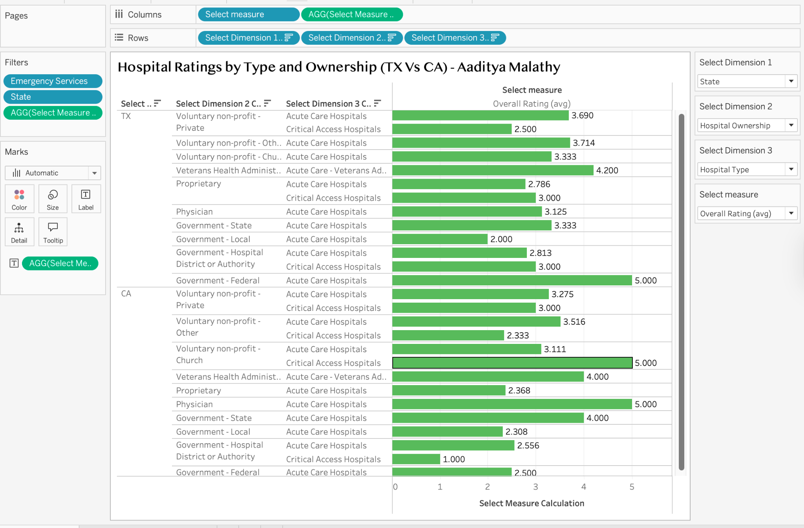

Justification:
This chart shows how the hospital ratings of Texas (TX) Vs California (CA) vary by state, ownership and hospital type in the parameters. I have used three-dimensional parameters here, and one measure is also selected as the measure for the Overall rating. I had to paint my charts green as I am fond of green colour. In conclusion, I have filtered to 2 states, TX & CA, the topmost states in healthcare quality, and to show the results of these 2 states, which is strong on these ratings, my chart shows a right demonstration, has multiple interactivities, and to tell my audience the right insights.

My Business Insights:
- Both states have better voluntary non-profit hospitals, making the highest average compared to just for-profit hospitals. This makes sense when we look into the link between the ownership model and the quality of care.
- California hospitals have more variations across hospital ownerships, whereas the Texas hospitals show more of conventional types, yet the non-profits are outperforming other types.
- Acute care hospitals show better quality of care compared to critical access hospitals. Large hospitals show that they have strong resources and better quality of care.

Chart 2: Which state patients get the best quality of care:
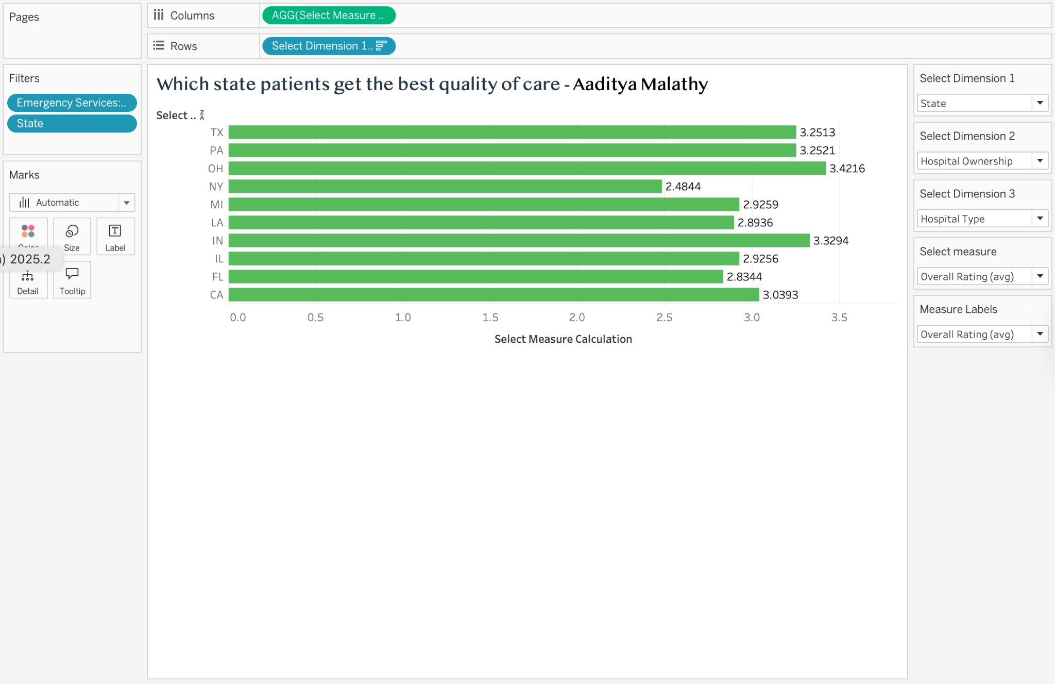

Justification:
In this chart, I have shown the Top 10 states in hospital count, which shows the best quality of care. The CMS dataset is very comprehensive, with more than 5000 hospitals, so I narrowed it down to have a balance that will show the right analysis. After filtering the states, in parameter Select Measure I, it has the flexibility to show the overall ratings, safety, readmissions and mortality measures from the dataset.

My Business Insights:
- My visualisation shows that Ohio and Indiana are the best in quality of care in the top 10 states.
- Even though Texas and California have larger hospital networks, smaller states like Ohio and Indiana show better quality of care. This shows that large hospital networks don't always correlate with the best quality of care.
- New York shows the lowest in the chart, indicating that there are numerous patient challenges in quality of care, and an HCO is needed to improve it.

My AI Disclaimer Statement:
In this Assignment, I have not used any Artificial Intelligence (AI), all my charts, writings, and analyses were completed by me. The Scribbr tool was used to assist in making APA 7 references.

References:
- Centres for Medicare & Medicaid Services. Hospital general information - Data set. U.S. Department of Health & Human Services.
- Boyce, D. Data visualisation: Creating parameters - PDF. University of North Texas.

